Purpose

Set up a set of workspaces to contain all the required entities to extract data from a Datasource and pass the data to a report. Configure the workspaces so that only one group has permission to edit the entities. Also, grant read-only permissions to a single workspace to one group.

--------------------------------------------------------------------------------------------------------------------------------------------------------

In this example, there are three workspaces.

A Quorum Journey – this workspace will contain reports and associated entities.

A Quorum Journey [DS] – this workspace will only contain **Data Sets**

A Quorum Journey [DF] - this workspace will only contain **Data Flow’s**

How to access the workspaces

1. Go to <https://app.powerbi.com/> and log in
2. Go to the left-hand side and click on the workspaces icon (see 1 in the screenshot below)
3. This will list all the workspaces your account has access to.

Workspace - A Quorum Journey [DF] - Roles

Workspace - A Quorum Journey [DS] - Roles

Workspace - A Quorum Journey - Roles

As can be seen from the screenshots above, the only workspace with a ‘viewer’ role is assigned to a group. The ‘A Quorum Journey’ workspace only contains reports/dashboards. This will ensure that any user in the group ‘All Quorum Users’ can view entities in that workspace. However, users in that group **cannot see** the workspaces ‘A Quorum Journey [DF]’ and ‘A Quorum Journey [DS]’.

The report ‘A_Quorum_Journey_Stage2’ is configured to use the dataset ‘Quorum_Strava_Dataset_OnlyStage2’ as the data source. Dataset ‘Quorum_Strava_Dataset_OnlyStage2’ the data source is configured as the dataflow ‘Stage2.’

**A Quorum Journey [DF]**

**Quorum_Strava_Dataset_OnlyStage2**

**A Quorum Journey [DS]**

A_Quorum_Journey_Stage2

**A Quorum Journey**



Stage2



**Configure dataset**

From the menu on the left-hand side of the window, select ‘Datasets’ see one on the screenshot below. Next, find the dataset you wish to work with; in the example, the dataset is ‘Quorum_Strava_Dataset_OnlyStage2’. Click on the dataset, and three dots will appear to see item 2 on the screenshot below. From the menu that appears, click on ‘Manage permissions’

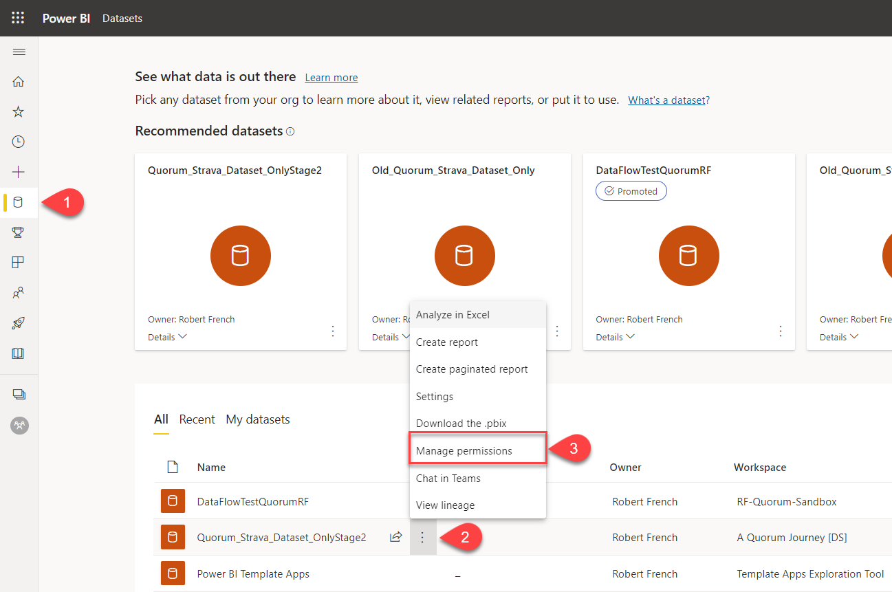

The ‘Manage permissions’ screen is shown below; the first step is to click on the ‘Add user’ button below.

Once the ‘Add user’ screen appears, select the group which want to add permissions to the DataSet. In the example below, one group is being added is ‘All Quorum Users’. Note all the three tick boxes are unselected; in this example, we do not want to grant these permissions. Once all the user groups have been selected, click on ‘Grant Access.’

Once the user has been added, that group will be granted ‘Direct access’, which is read (only) permission. In the screenshot below, the group ‘All Quorum Users’ has been added and granted ‘Read’ permissions.

This setting allows the group ‘All Quorum Users’ to read-only access to the dataset in the workspace ‘A Quorum Journey [DS]’. Note that the group ‘All Quorum Users’ has no permissions on ‘A Quorum Journey [DS]’. It only has Read permissions on the DataSet ‘Quorum_Strava_Dataset_OnlyStage2’, which is the data source of the report ‘A_Quorum_Journey_Stage2’.

Final result

The group ‘All Quorum Users’ has viewer (read-only) access to the workspace ‘A Quorum Journey’ and the entities in that workspace. So the group can view and interact with the reports in that workspace, the group cannot edit anything in that workspace.

The data source (dataset - Quorum_Strava_Dataset_OnlyStage2’) is not visible to the group ‘All Quorum Users’. Nor does the group have permission to use the dataset to build reports from that dataset.